Assessment task 2

Ciarán Maher 7th-March-2016
Design document for Airline Booker 9001®

Data Flow Diagrams

DFD Level 0
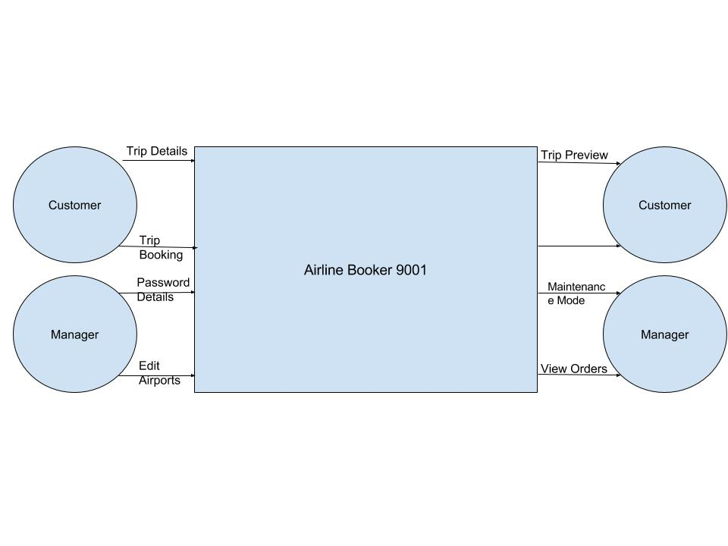
Customer selects the details of a new trip and previews the booknig. When the customer confirms the details, the booking is saved to the file.
Manager enters password details to enter the maintenance mode. Once in maintenance mode, the manager can Add and/or Delete Airports. When changes are confirmed, the new airport list is saved to the file.

DFD Level 1
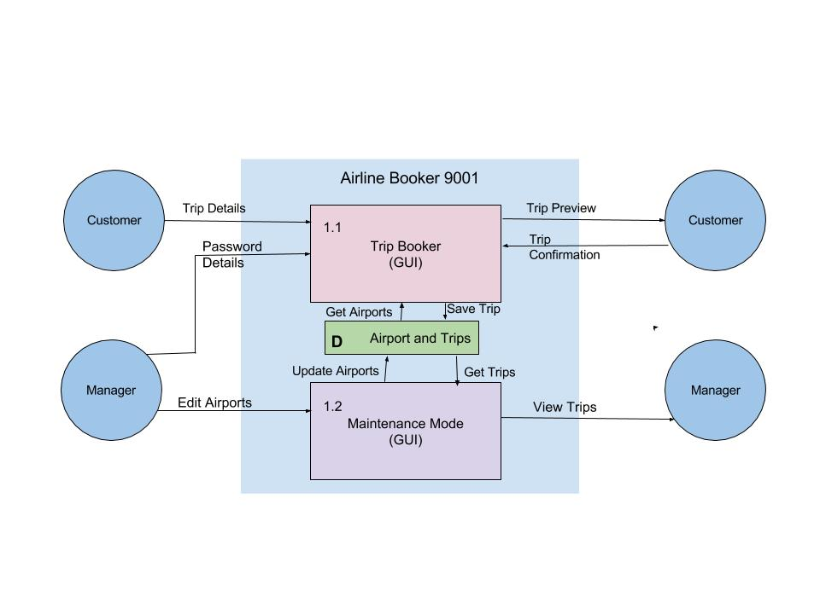
In the DFD Level 1, we can see an even greater breakdown of the structure of the Airline Booker 9001 code. The customer should only be dealing with the Trip Booker GUI elements and have no need (or ability) to access the maintenance mode.

DFD Level 2

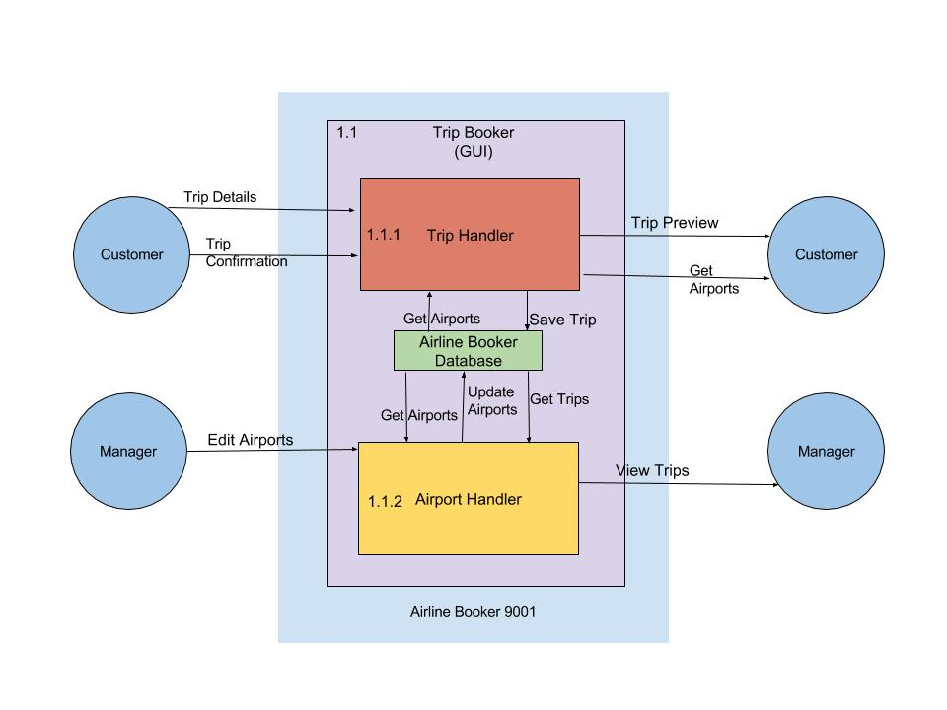
In the DFD Level 2 we can see a further breakdown of the structure of the code for the Airline Booker 9001. Airport handling (and other file handling) is carried out completely by the Airport Handler. Allowing managers to edit airports and view trips and customers to book their trip seamlessly.

Pseudocode for necessary methods

getAirports()
- Open a new file reader with the required file.
- Parse the airports from the file to a list and return that list.
This method is required to pull airport details from the file, so they can be displayed to the user and manipulated (edited) by the manager.

saveAirports()
- Open a new file writer with the required file.
- Parse airports from the list to the file and append all changes (Deletion/Addition)
This method is neccessary to save any changes made by the manager in maintenance mode. All details will be saved to the same file that the program must read from, so care must be taken to ensure the “sanity” of the airport records file.

getTrips()
- Open a new file reader with the required file.
- Parse the Orders from the file to a string and return that string.
This method is used to collect all confirmed trips from the file so that they can be displayed to the manager.

saveTrips()
- Open a new file writer with the required file.
- Parse order from the list to the file and append all details.
This method is required to save any new confirmed trip to the file so that it can be reviewed later by a manager.

Objects, data and file structures

Trips
Each trip contains a list of all of the necessary details for the successful completion of the trip. This includes the customer name, the departure/destination points, the booking ID, the seat type, the number of stops and whether carry-on luggage is required; this can be summarised as such:
Customer name : | userName
Customer ID : | UUID
Seat Type: | Economy class  Business class  First class
Number of Stops: | 01/02/03
Departure/Destination: | a to b
 | c to d
 | e to f
Carry-on Luggage: | Yes/no

Type
As such, there are 6 constants neccessary for the creation of the Airline Booker 9001.
For the seat type, all Trips must have a seat type of either Economy Class, Business class or First Class.
For the number of stops, all trips must be 1 stop, 2 stops, or 3 stops. They have been named internally as “One-way”, “Return” and “Journey”, respectively.

